Auto Ticket Classification using Flow Designer
Final Project Report
Project Documentation | Date: 01 October 2026 | Team: Not specified in project brief
1. INTRODUCTION
1.1 Project Overview
The project automates school IT helpdesk ticket classification using ServiceNow Flow Designer. Students and teachers provide a caller and short description; the system creates a structured Incident Workflow record, evaluates keywords, assigns Category and Subcategory, and sends an acknowledgement email.
1.2 Purpose
The purpose is to reduce manual categorization, improve routing consistency, reduce response friction, and provide a maintainable no-code solution that can scale to more issue types.
2. IDEATION PHASE
2.1 Problem Statement
The school IT helpdesk receives recurring Wi-Fi, projector, password, and slow-computer requests. Manual review consumes agent time, creates classification inconsistency, and delays routing.
2.2 Empathy Map Canvas
Students and teachers want a quick, low-effort submission and confirmation. IT agents want standardized fields and correctly routed work. Administrators want maintainable rules and controlled access.
2.3 Brainstorming
The selected idea was deterministic keyword classification with dependent choice logic, a structured custom table, email acknowledgement, update-set portability, and validation scenarios.
3. REQUIREMENT ANALYSIS
3.1 Customer Journey Map
The journey is: issue noticed → description submitted → record created → Flow Designer classifies → ticket routed → caller receives confirmation → agent resolves ticket.
3.2 Solution Requirements
ID | Requirement | Outcome
FR-1 | Capture ticket and caller data | Structured Incident Workflow record
FR-2 | Classify by keywords | Category and Subcategory assigned automatically
FR-3 | Use dependent choices | Valid subcategories mapped to categories
FR-4 | Notify caller | Email acknowledgement after creation
NFR-1 | Maintainability and scalability | No-code configurable rules and update sets
3.3 Data Flow Diagram
Caller input flows into the Incident Workflow record, then through Flow Designer keyword evaluation, field updates, routing data, and caller email notification.
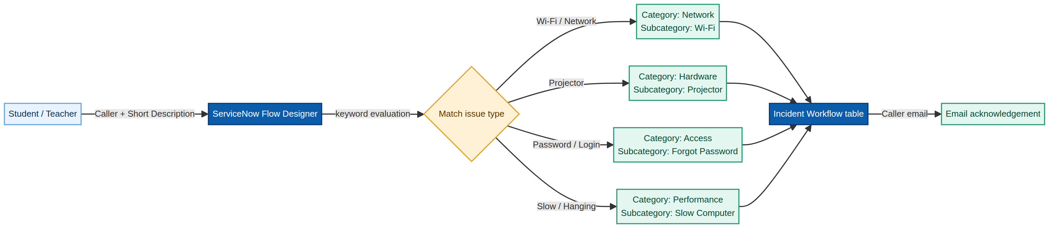
3.4 Technology Stack
Platform: ServiceNow. Automation: Flow Designer. Data: Incident Workflow custom table with reference and choice fields. Deployment: Project Update Set and XML export. Notification: ServiceNow email action. No external API or machine-learning model is required.
4. PROJECT DESIGN
4.1 Problem–Solution Fit
The solution fits the existing behavior because the caller uses the familiar ticket form and email channel while the helpdesk gains automated classification and standardization.
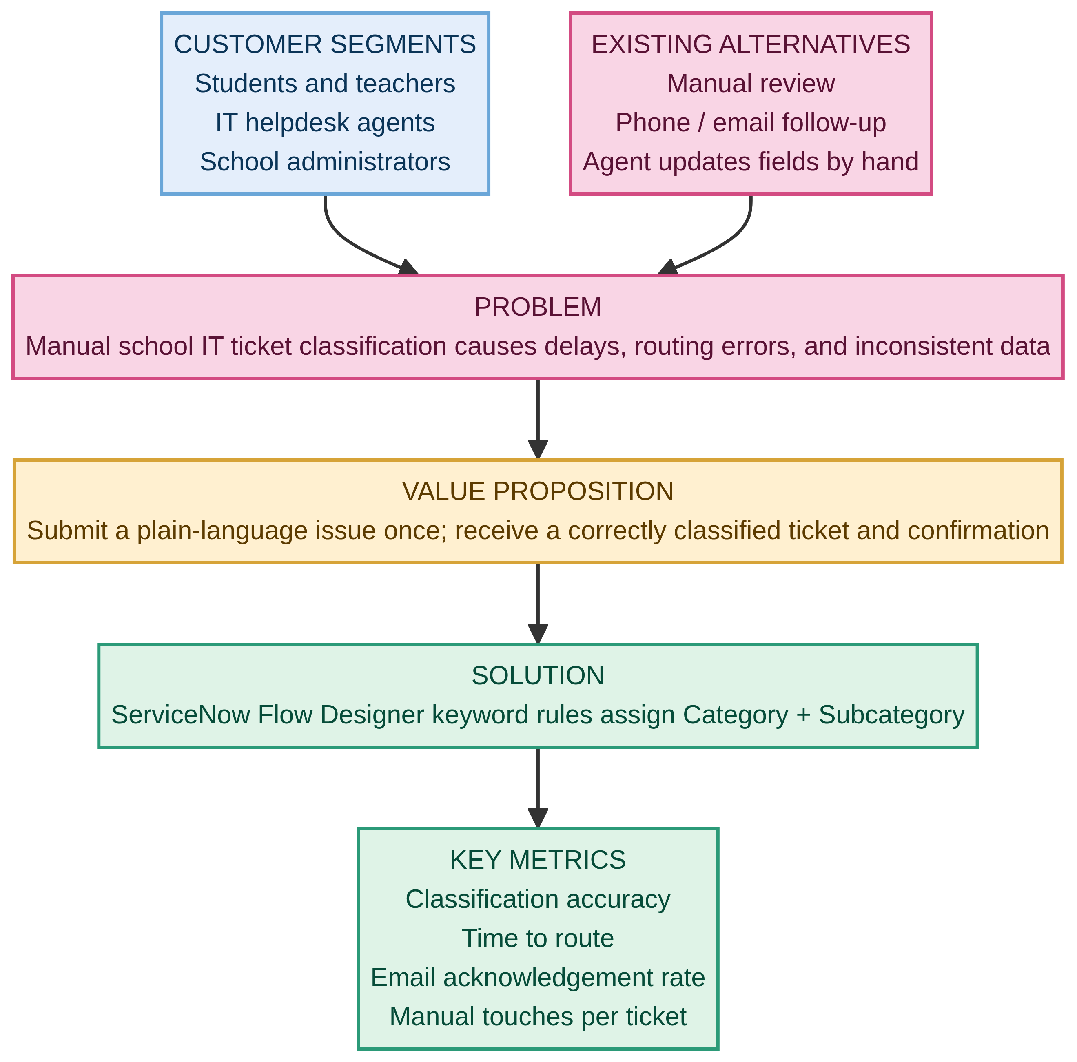
4.2 Proposed Solution
Create the table and fields, configure Category/Subcategory dependencies, activate the “Auto Classify School IT Tickets” flow, update records based on WiFi/Projector/Password/Login/Slow/Hanging keywords, and send the confirmation email.
4.3 Solution Architecture
5. PROJECT PLANNING & SCHEDULING
5.1 Project Planning
Three sprints were planned: Sprint 1 requirements and data model (11 points), Sprint 2 automation and communication (7 points), and Sprint 3 validation and deployment (5 points). Total planned effort is 23 story points and planned average velocity is 7.67 points per sprint.
6. FUNCTIONAL AND PERFORMANCE TESTING
6.1 Performance Testing
Functional tests cover ticket intake, four keyword classifications, dependent choices, state values, and email notification. Performance tests cover classification response time, controlled burst creation, duplicate auto-number checks, flow failures, and notification throughput. The supplied test plans identify expected outcomes and require actual evidence from the ServiceNow environment.
Test ID | Scenario | Expected result
FT-02 | Wi-Fi keyword | Network / Wi-Fi
FT-03 | Projector keyword | Hardware / Projector
FT-04 | Password/Login keyword | Access / Forgot Password
FT-05 | Slow/Hanging keyword | Performance / Slow Computer
PT-01 | Response time | Within agreed helpdesk threshold
7. RESULTS
7.1 Output Evidence
The planned output is a classified Incident Workflow record and a caller email acknowledgement. Evidence should include the saved record, field values, flow execution, email log, and test result for each scenario. No unverified execution result is claimed in this report.
8. ADVANTAGES & DISADVANTAGES
Advantages: no-code maintenance, consistent classification, lower manual effort, faster routing, dependent data quality, email confirmation, update-set portability. Disadvantages: keyword rules may miss synonyms or ambiguous text, classification depends on accurate descriptions, and additional issue types require rule maintenance.
9. CONCLUSION
The project delivers an end-to-end ServiceNow automation design for school IT support. It addresses the manual classification problem through structured records, deterministic Flow Designer rules, dependent choices, notification, testing, and deployment documentation.
10. FUTURE SCOPE
Add fallback/manual-review routing, synonym dictionaries, dashboards and SLA analytics, additional issue categories, richer audit history, multilingual keywords, and integration with service catalogs or knowledge articles.
11. APPENDIX
Source code: No custom source code; configuration is maintained in ServiceNow and captured in the Project Update Set. Dataset link: Not applicable; test data consists of controlled school IT ticket descriptions. GitHub / demo link: Not provided. Related deliverables: Requirement Analysis, Project Design, Project Planning, UAT, and Functional/Performance Testing documents.

